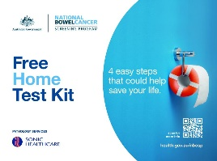**Keep a manual tally of the number of National Bowel Cancer Screening Program kits handed out during the mini activity ✓**

Activity time frame: __________________________________________

Name of Clinician: ___________________________________________

*Please use the space below to keep track of how many kits you've given to patients (e.g. by using tallies or checkmarks).*

|  |  |  |  |  |
| --- | --- | --- | --- | --- |
|  |  |  |  |  |
|  |  |  |  |  |
|  |  |  |  |  |
|  |  |  |  |  |
|  |  |  |  |  |
|  |  |  |  |  |
|  |  |  |  |  |
|  |  |  |  |  |
|  |  |  |  |  |
|  |  |  |  |  |
|  |  |  |  |  |
|  |  |  |  |  |
|  |  |  |  |  |
|  |  |  |  |  |
|  |  |  |  |  |
|  |  |  |  |  |
|  |  |  |  |  |
|  |  |  |  |  |

**TOTAL =**