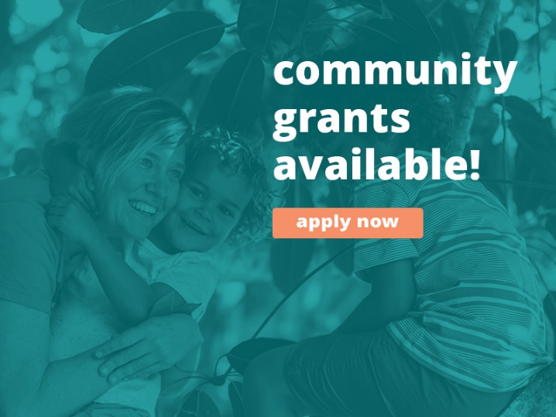

Community Wellbeing Grants
Jimboomba, Beaudesert & Surrounds

Information Session Q&A
A Community Information Session was held on 24 April and the following questions were discussed. If you have further questions regarding the Community Wellbeing Grants, please contact us.

Q: If we had multiple projects, can we apply for more than one grant?
- Yes, you can submit multiple applications or alternatively group related projects into one application if under $20,000.

Q: Can the project occur outside the region?
- Yes, but it needs to target the community within the specified region.

Q: Does Brisbane South PHN need photos from the project?
- We would love them, and will supply successful applicants with Media Consent Forms, but this is not contingent to approval.
Q: Are other PHNs providing similar grant opportunities for the region?
- Not that we are aware of.
Q: Do you need to provide a copy of certificate of currency for insurance and public liability?
- At the submission of your grant application, you will not be required to submit proof of insurances, however these may be requested.
Q: Can we apply with a collaborative project between multiple services or groups?
- Yes, collaborative projects are encouraged. Auspice arrangements are also accepted for those not registered as not-for-profit providers, in collaboration with a registered not-for-profit.
Q: Can you target wellbeing as opposed to mental ill-health?
- Yes, the grants are designed to support community wellbeing – this may look like projects that target social, emotional, cultural or psychological wellbeing.
Q: Will the successful projects be reviewed upon completion for ongoing funding?
- No, these are one-off grants and we encourage planning for sustainability.
Q: Are murals and wellbeing awareness projects suitable for the grants?
- Yes, community awareness projects are suitable and would meet the grant objectives.
For more information
 https://bsphn.org.au/about/opportunities/grants-and-eoi
 mhspaod@bsphn.org.au
 1300 467 265

